[\\renga-w7\softwares\ideaIC-2017.1.exe](file:///\\\\renga-w7\\softwares\\ideaIC-2017.1.exe)

1. Pull Code from Git

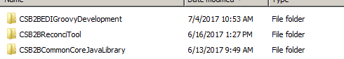

1. Open Idea

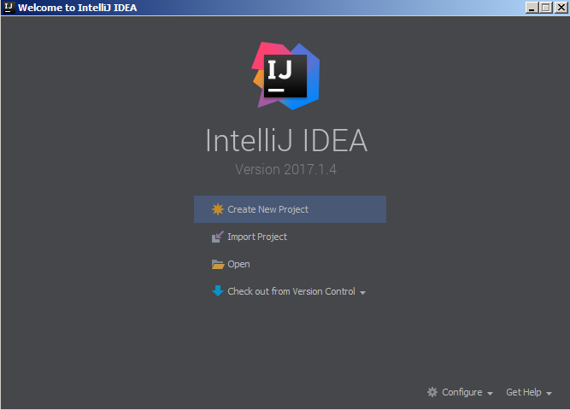

1. Click Open, choose project “CSB2BEDIGroovyDevelopment” path

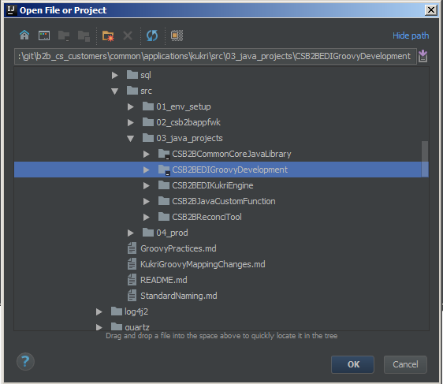

1. 3 projects are imported

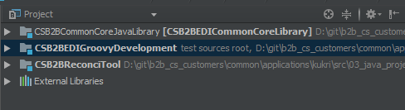

1. Update Compile heap size in File -> setting -> Build, Execution, Deployment -> compiler -> Build process heap size -> 1024

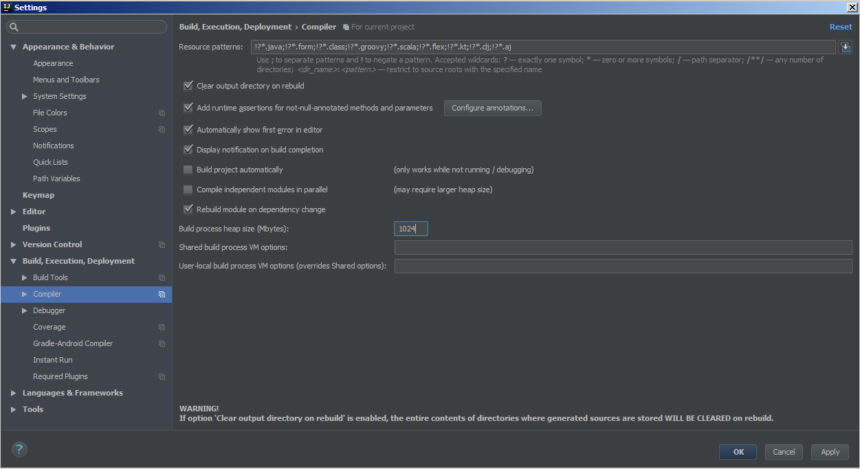

1. Run and work, it needs long time in first compile, please wait patiently.